
Presbyterian Women in the Synod of Southern California and Hawaii
CHURCHWIDE GATHERING SCHOLARSHIP APPLICATION FORM
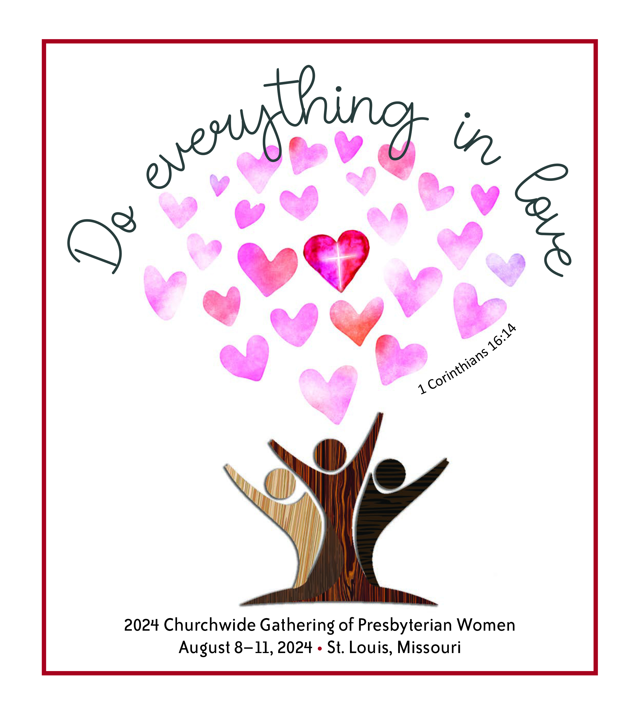

August 8-11, 2024
St. Louis, Missouri

Scholarship Information:
Up to four $1,000 scholarships will be awarded.
Recipients must be willing to share at the PWS Fall Gathering
Deadline for applications is May 10, 2024
Send application form to:
Pam Hodges, 8101 Dunbarton Avenue, Los Angeles, CA 90045
or PamHaji@ca.rr.com

This form can be completed online, saved, and returned as an attachment to Pam Hodges. If you prefer to complete a paper copy, please use the attached PDF instead.

Name
Address
City
State _ Zip
Phone_
E-Mail
Presbytery

Church

(The form will expand to accommodate your reply, below, for the next three questions.)

- Please tell why you would like to attend the Churchwide Gathering:

- What is your current involvement in Presbyterian Women?

.3 How can you be more involved over the next three years?

Please save this form and return it to PamHaji@ca.rr.com

